**NLP RESULTS:**

**Prediction of Next Word:**

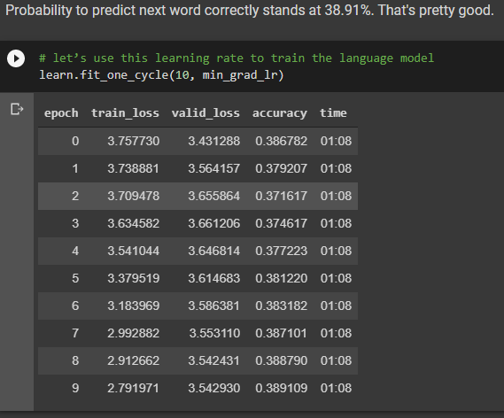

**Probability After Unfreezing the Rest of the Network:**

